User Manual: SSD Institute Web Portal

Prepared by:
Thom Mondeaux • Austin Pringle
Stuart Krueger • Justin Maga

CMIS-4920: Senior Capstone II
April 11, 2026

Version 1.0

Contents
System Overview 4
What is the system? 4
What problem does it solve? 4
Who is the target user? 4
System Access 5
Front-End User (General Public & Non-Profits) 5
Back-End User (Developers & Data Administrators) 6
Navigation Overview 7
Global Navigation Header 7
Concept Research & Definition Pages 8
Interactive Visualization Suite 8
Footer and External Links 10
Core Features 11
Collaborative Veto 11
Supreme Court Check 12
Multiple-Choice Voting 13
Accessibility 14
Validation & Error Handling 16
Outputs / Results 17
Known Limitations 17
Recent System Improvements 18
Future Improvements 18
Sidebar Menu (Navigation Expansion) 18
Additional Improvements 19
Glossary 20
Governance & Political Terms 20
Technical & Web Terms 20

System Overview

What is the system?
The Scientific Self-Determination (SSD) Project is a civic education platform designed to empower the general public and non-profit organizations by simulating alternative governance models through an interactive Flask web application. The application uses data visualizations to demystify complex concepts like collaborative vetoes and multi-choice voting, helping citizens understand how local empowerment and direct participation can shift political decision-making. By providing these clear, visual tools, the project aims to foster informed consent in government and inspire discussions regarding more adaptable, representative democratic systems.

What problem does it solve?
The project addresses the broader issue that most people have limited visibility into how governance structures shape political outcomes, and it reduces those barriers by turning abstract theories into clear, visual models. It shows how different voting rules and veto thresholds shift decision-making power, demonstrates how Multi-choice Voting can reduce spoiler effects and allow voters to express broader preferences, explores ways to decentralize authority through tools like the Collaborative Veto and Supreme Court Veto, and introduces the Minimum Amount of Space concept as a rights-based alternative to traditional welfare programs that focuses on stability and independence.

Who is the target user?
The system is built for three main groups: the general public, who want a clearer and more hands-on understanding of how different governance systems work; non-profit staff and volunteers, who use the platform to educate local communities and support civic engagement; and academic reviewers, including faculty and peers, who evaluate the project’s technical and conceptual strengths

System Access
The SSD Project distinguishes between those who interact with the simulations and those who maintain the data architecture.

Front-End User (General Public & Non-Profits)
The front-end user is any citizen or organization member using the site as an educational resource.
- Access Method: Open any modern web browser (Chrome, Firefox, Safari) and navigate to www.ssdinstitute.net.
- Authentication: No login or password is required for front-end access.
- Permissions: Front-end users have "Read and Interact" permissions, allowing them to view concept pages and toggle simulation data. An image of the homepage is shown below in Figure 1.
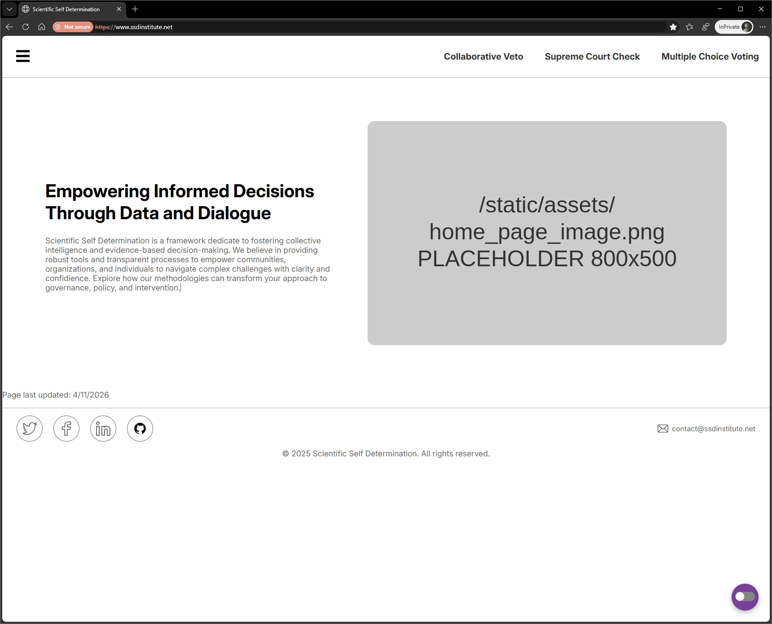
Figure 1. Homepage layout of the Scientific Self Determination website, highlighting its mission statement and
navigation structure.

Currently there is not a dedicated SSL certificate (the "HTTPS" padlock) has not yet been applied to the custom domain. Because of this, your web browser may flag the site as "Not Secure".
Steps to Access the Site
If you encounter a "Your connection is not private" or "Warning: Potential Security Risk" message, follow these steps to proceed to the simulation:
- Click "Advanced": On the warning screen, look for a button labeled Advanced or More Information.
- Select "Proceed": Click the link that says Proceed to www.ssdinstitute.net (unsafe) or Accept the Risk and Continue.
- Confirm Navigation: The site will then load normally, allowing you to use all interactive features.

Back-End User (Developers & Data Administrators)
The back-end user or nonprofit liaisons who handle updates to the governance models.
Access Method (Hosting): Managed through the PythonAnywhere dashboard.
Access Method (Code): Managed in the GitHub repository using standard Git commands (git pull, git push).
Workflow:
- Data Updates: New election or judicial data is added to the /data/raw/ directory.
- Processing: The mcv_viz_prod.py script is run to convert raw data into interactive HTML visualizations.
- Deployment: Changes pushed to the main branch trigger the automated CI/CD pipeline, updating the live site.
- Permissions: Back-end users have full administrative access to the Flask scaffold, virtual environment, and database-related scripts.

Navigation Overview
The SSD Institute web application is structured to provide a seamless transition from theoretical governance concepts to interactive, data-driven simulations. The navigation system is divided into three primary zones: the Global Header, the Concept Research Section, and the Interactive Visualization Suite.

Global Navigation Header
Located at the top of every page, the header serves as the primary anchor for the system. It allows users to jump between the four core pillars of the project without losing their place.
- Collaborative Veto (Blue Outline): This is the first text-based tab in the group on the right side of the bar, marked by the blue outline in Figure 2. It directs the user to the simulation of local-level decision-making and minority overrides.

- Supreme Court Check (Green Outline): This is the center tab in the right-hand navigation group, marked by the green outline in Figure 2. It links to the interactive U.S. map visualization where states can collectively review judicial rulings.

- Multiple Choice Voting (Red Outline): This is the final tab on the right side of the navigation bar, marked by the red outline in Figure 2. It opens the election simulation tool that models alternative voting systems using historical data.

Figure 2. shows the main navigation view of the Scientific Self Determination site, including the three core governance model options.

Concept Research & Definition Pages
Each individual concept page acts as a comprehensive educational module designed to be read from top to bottom before engaging with the simulation tools.
- Definition & Context: Each page begins with a non-technical explanation of the governance model and its historical roots, such as the Virginia/Kentucky Resolutions for judicial checks or Concurrent Majority theory for vetoes.
- Data Sources: To maintain transparency, every page includes citations for the datasets used, including the Federal Election Commission (FEC), National Archives, Oyez, and the Census of Governments.
- "Last Updated" Stamp: A timestamp at the bottom of the content area (e.g., "Page last updated: 4/11/2026") marked by the red outline in Figure 3. indicates exactly when the research and simulation data were most recently verified.
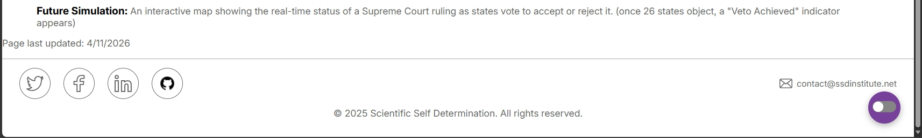
Figure 3. The update timestamp and site attribution details

Interactive Visualization Suite
The core of the experience is the Visual Interface embedded within the concept pages.
- Interactive Controls: Users can engage with JavaScript-driven "switcher bars" and toggle controls to swap between different historical case studies or election simulations without a full page reload. marked by the red outline in Figure 4.
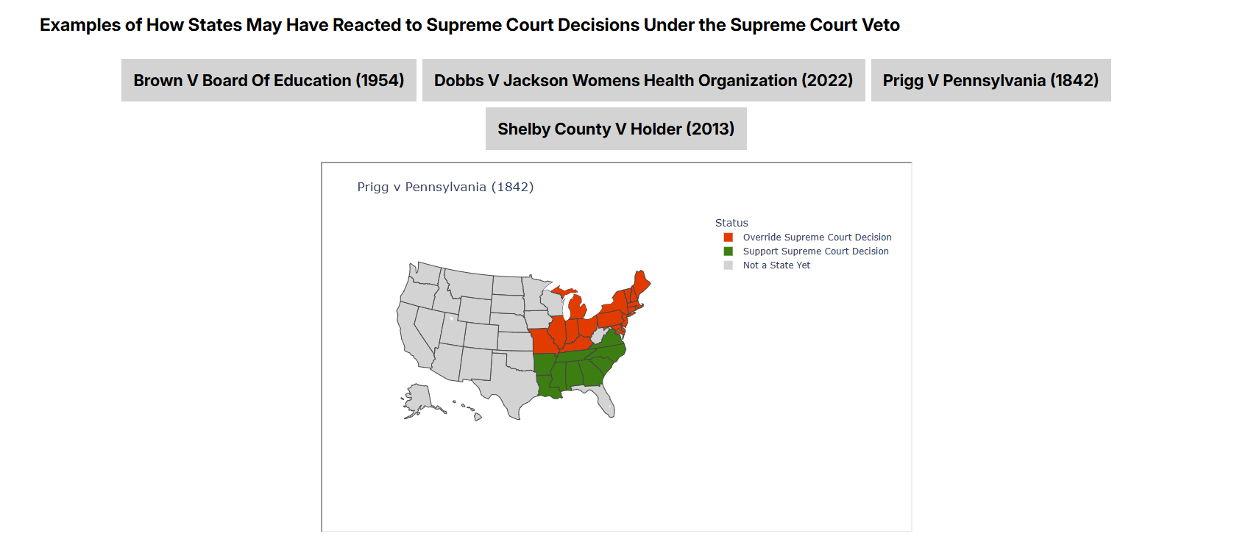
Figure 4. Visualization showing how states may have responded to the Prigg v. Pennsylvania decision under the
Supreme Court Veto model, with states color-coded by reaction category.
- Hover-States & Tooltips: Navigating your cursor over specific map regions or chart bars will trigger tooltips that provide specific data points, such as exact vote counts or state-level legislative sentiment. marked by the red outline in Figure 5.
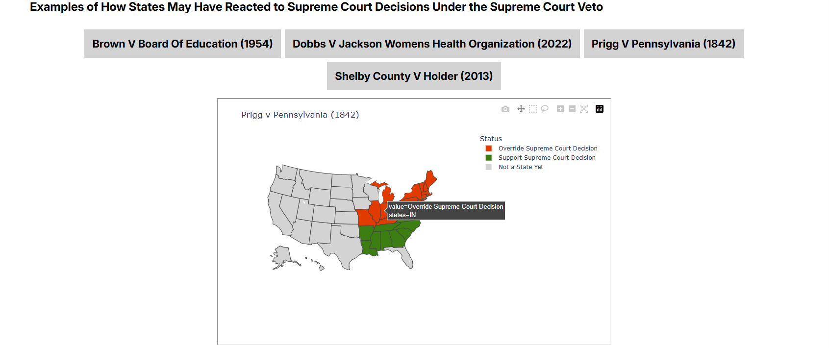
Figure 5. Interactive map view for Prigg v. Pennsylvania, showing state-level reactions and an example tooltip
indicating a state’s classification.
- Dynamic Visuals: The suite provides immediate feedback through color-coded choropleth maps and bar charts that reflect the selected governance model. marked by the red outline in Figure 6

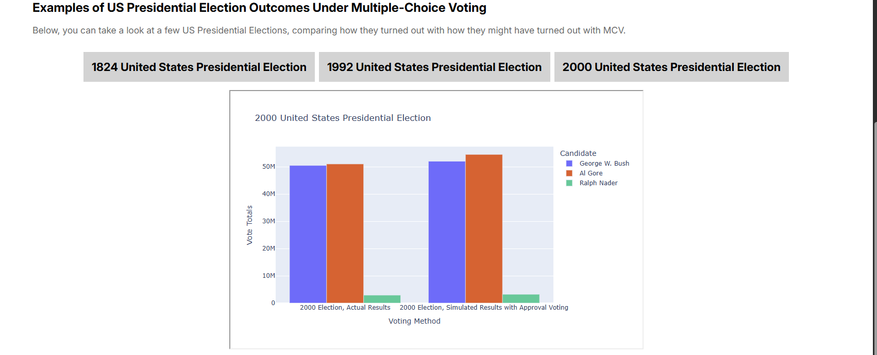
Figure 6. Comparison of actual 2000 U.S. Presidential Election results with simulated outcomes under
Multiple-Choice Voting, illustrating differences in candidate vote totals.

Footer and External Links
The footer provides persistent access to administrative and support channels.
- Social Icons: Quick-access buttons for Twitter, Facebook, LinkedIn, and the GitHub repository for users interested in the development workflow or documentation .marked by the blue outline in Figure 7.
- Copyright & Ownership: Confirms the project's non-profit status and official ownership by Scientific Self-Determination. marked by the green outline in Figure 7.
- Contact Information: A dedicated link to the project email (contact@ssdinstitute.net) for general inquiries. marked by the red outline in Figure 7.

Figure 7. Footer layout displaying social media links, copyright notice, and contact information.

Core Features
The SSD Institute platform provides interactive tools to help users explore alternative governance models. Each feature is designed to transform complex political theories into visual simulations.

Collaborative Veto
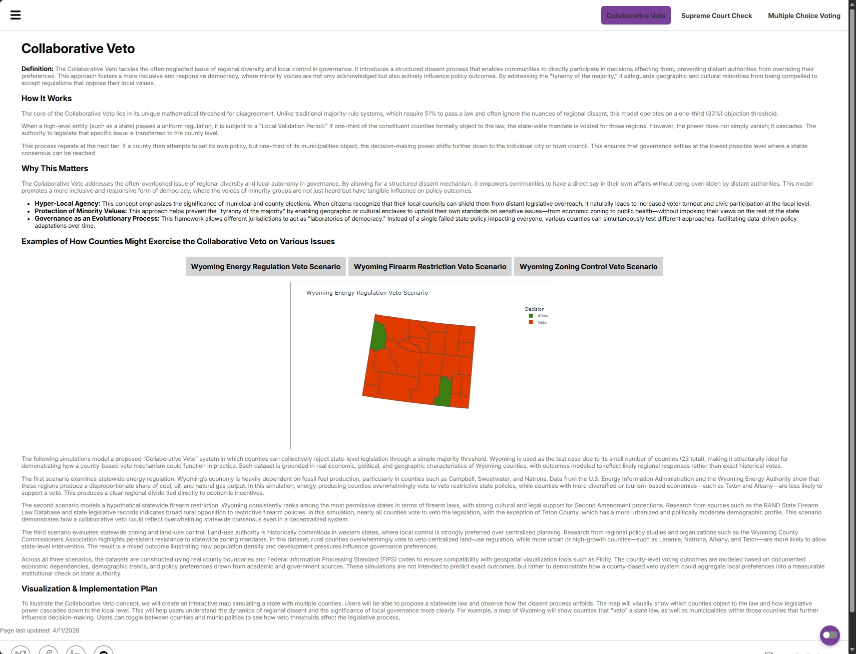
Figure 8. Overview of the Collaborative Veto model, showing how county-level simulations illustrate regional dissent and how authority shifts to local jurisdictions
Purpose: This tool demonstrates the "cascading veto," a model where decision-making power is pushed down to the most local level possible. It ensures that a significant minority (33%) can prevent a higher authority from imposing a one-size-fits-all law.
Navigation: Identified by the blue outline in the Global Navigation Header (Figure 2).

Mechanics & Steps:
- Select the Tab: Click the first tab on the right side of the name bar.
- Examine the Wyoming Model: Review the static map that models a hypothetical state-wide ban on a specific activity.
- Identify Thresholds: Look for counties where at least one-third of the population or municipalities "objected".
Historical Basis: Based on Concurrent Majority theory, which suggests that a government should require the consent of all its major interest groups to act.
Expected Output: A visualization showing that while a state may pass a law, individual counties can remain "opt-out" zones, preserving local self-determination.

Supreme Court Check
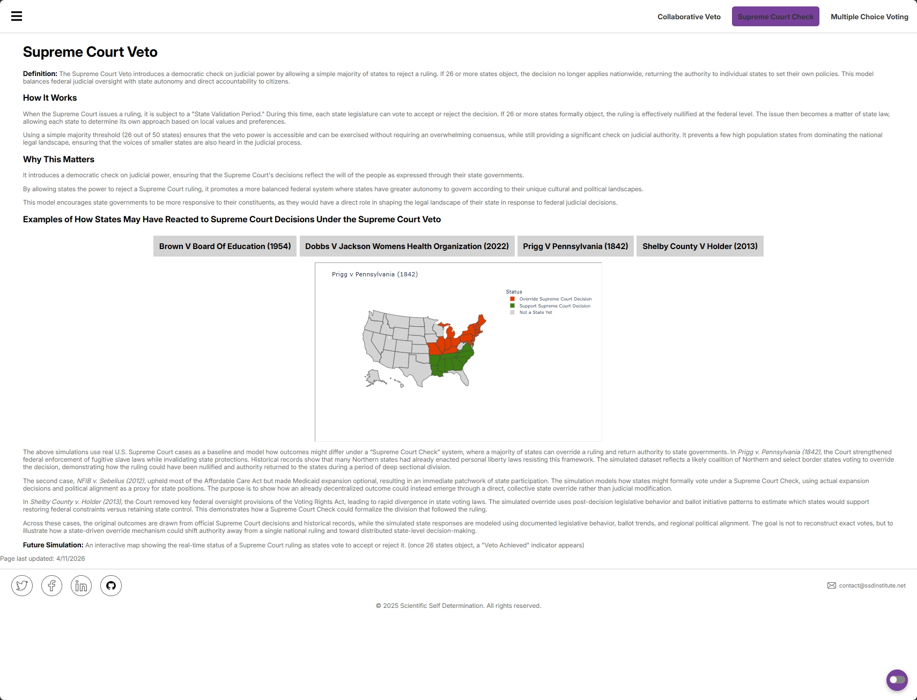
Figure 9. Overview of the Supreme Court Veto model, showing how states might respond to a ruling under a state-level validation process and how authority shifts when a majority of states reject a decision.
Purpose: This feature visualizes a democratic check on the judiciary. It models a system where a simple majority of 26 states can collectively "veto" a Supreme Court ruling, effectively returning that specific policy-making power back to the individual states.
Navigation: Identified by the green outline in the Global Navigation Header (Figure 2).
- Mechanics & Steps:
  - Select the Tab: Click the center tab in the navigation group.
  - Choose a Case: Use the switcher bar above the map to select real-world case studies like Dobbs or Shelby County.
  - Analyze the Map: Observe the color-coded U.S. states.
    - Support (Green): States agreeing with the ruling.
    - Override (Red): States formally objecting.
    - Mixed (Yellow): States with divided legislative or judicial sentiment.
Historical Basis: References the Virginia and Kentucky Resolutions, which argued that states have the right to declare federal acts unconstitutional.
Expected Output: If the red "Override" states reach 26, a "Veto Achieved" indicator appears, demonstrating a collective democratic reversal of a court decision.

Multiple-Choice Voting
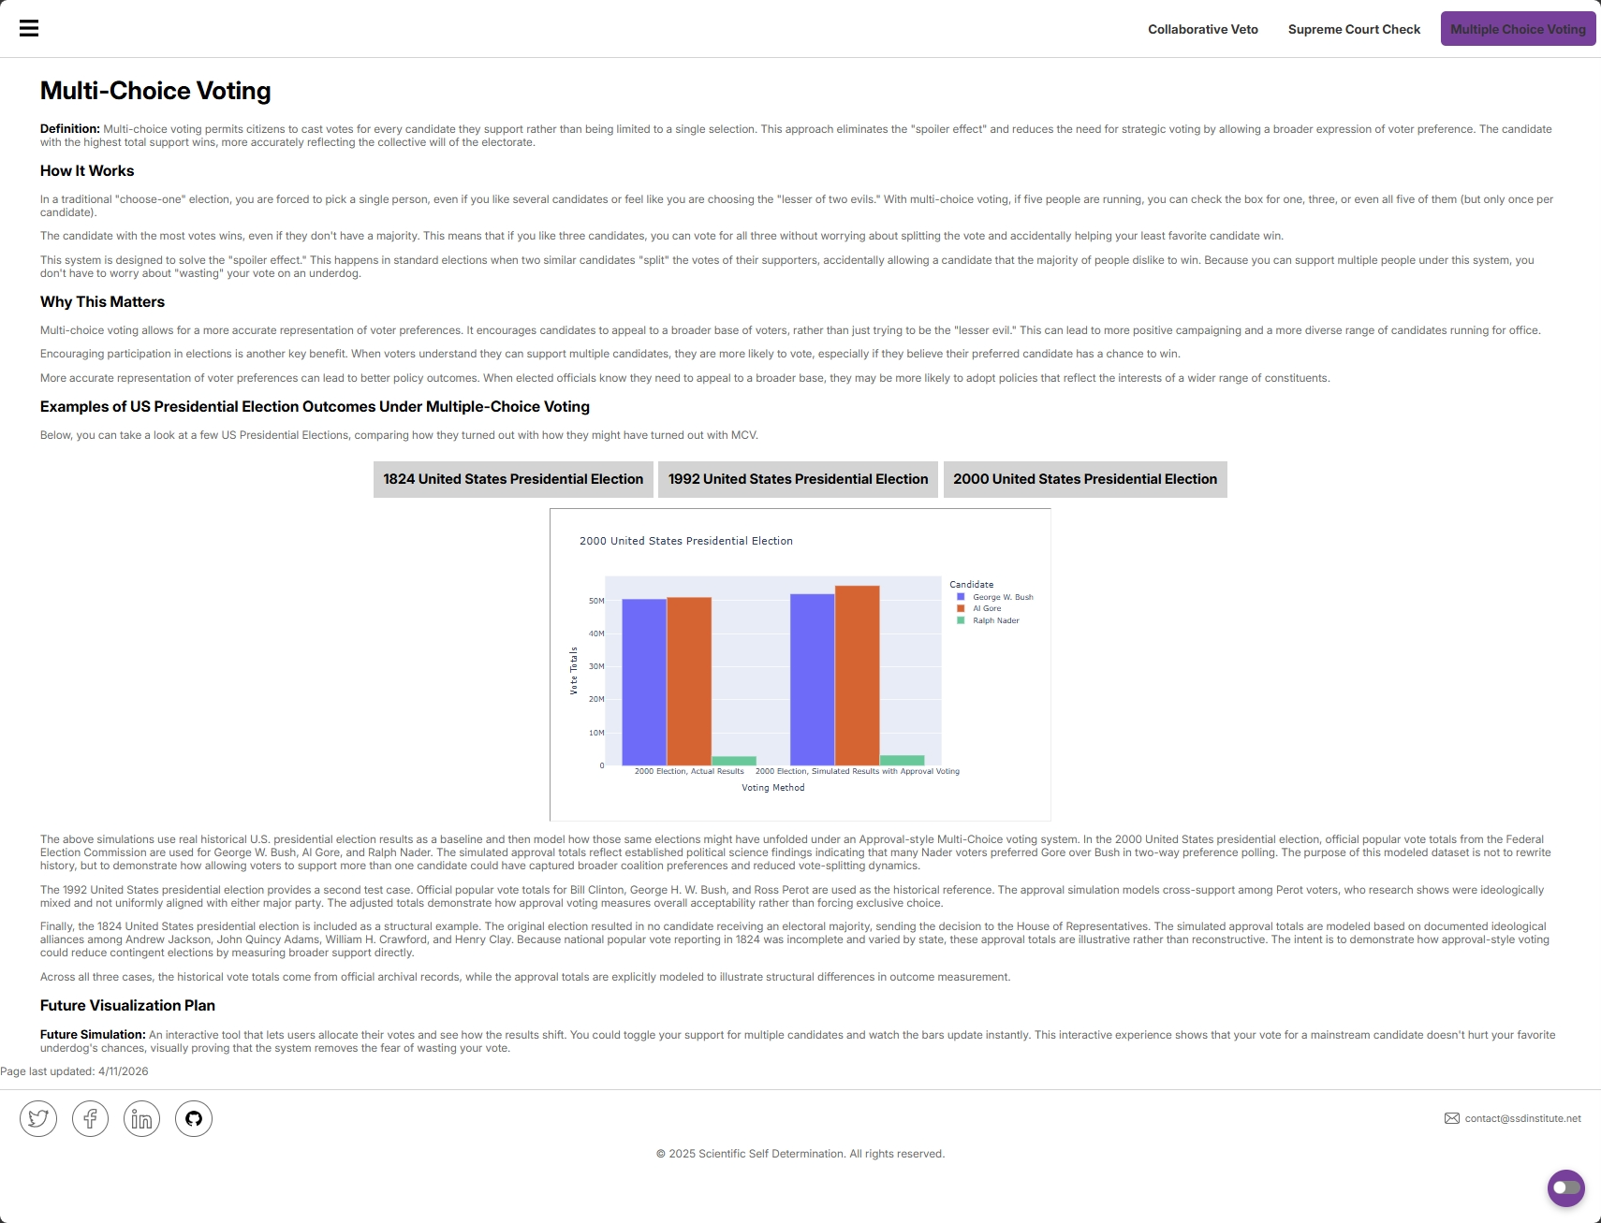
Figure 10. Overview of the Multi-Choice Voting model, illustrating how allowing voters to support multiple candidates can reduce the spoiler effect and better reflect overall voter preferences.
Purpose: This simulation explores "Approval Voting," where voters select all candidates they find acceptable. This eliminates the "spoiler effect" and reveals which leader has the broadest community support.
Navigation: Identified by the red outline in the Global Navigation Header (Figure 2).
Mechanics & Steps:
- Select the Tab: Click the final tab on the right side of the name bar.
- Toggle Historical Data: Use the simulation controls to switch between the 1824, 1992, and 2000 U.S. Presidential elections.
- Compare Results: View the "Plurality" (current system) results side-by-side with the "MCV" simulation.
Historical Basis: Uses official Federal Election Commission (FEC) and National Archives data to model how different outcomes could have occurred under alternative rules.
Expected Output: A bar chart that updates in real-time to show how the winner of an election might change when voters can express a broader range of preferences.

Accessibility
The Accessibility Button is designed to help users with different visual or cognitive needs interact with the governance simulations comfortably.
- Location: You can find the accessibility icon, a purple circular button with a toggle symbol, located at the bottom-right corner of your screen. marked by the red outline in Figure 11.
- Purpose: This feature allows users to customize the website's visual interface to improve readability and navigation.
- How to Use:
  - Click the Purple Toggle Button at any time.
  - Select from the menu of available adjustments.
- Available Functions:
  - High Contrast Mode: Adjusts the color palette to make text stand out more sharply against the background, which is particularly helpful for viewing detailed maps.
  - Text Scaling: Increases or decreases font sizes across the educational modules and data labels.
  - Screen Reader Optimization: Ensures that the structure of the "Definition & Context" sections is easily interpreted by assistive technology.
- Expected Output: The website's layout or color scheme will shift immediately to your selected preference without reloading the page.

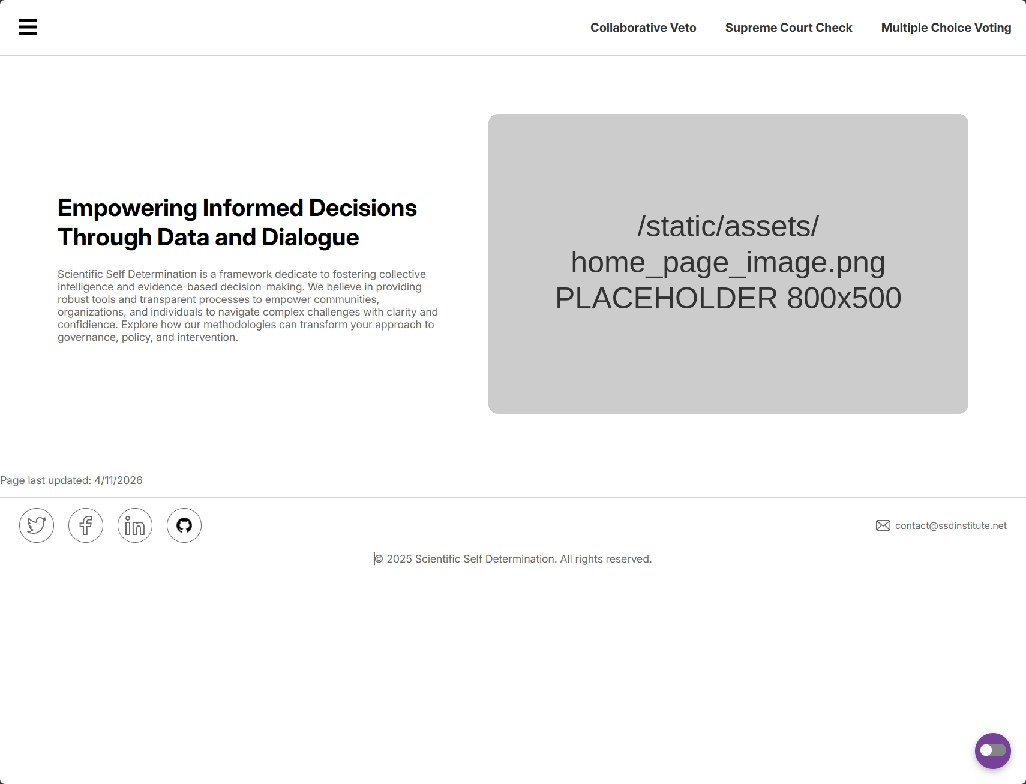
Figure 11. Homepage layout highlighting the accessibility menu button, which provides users with quick access to display and usability options.

Validation & Error Handling
While the SSD Institute platform is designed for ease of use, you may occasionally encounter issues related to browser settings or the site’s current development stage. The following bullet points outline the most common user errors, what they mean, and how to resolve them.
- “Your connection is not private”
  - The site is currently using HTTP because the SSL certificate is scheduled for a future sprint.
  - Click Advanced, then select Proceed to www.ssdinstitute.net (unsafe) to continue.
- “Visualization Not Loading”
  - Interactive Plotly or D3.js scripts failed to load, often due to cached data or a weak connection.
  - Refresh the page (F5) or clear your browser cache to reload the scripts.
- “Toggle Not Working”
  - Interactive switches for voting or map case studies require JavaScript to function.
  - Ensure JavaScript is enabled and confirm no script-blocking extensions are active for this site.
- 404 Page Not Found
  - You clicked a link for a feature still in development (e.g., Minimum Space simulation).
  - Use the Global Navigation Header to return to an active concept page such as Multiple Choice Voting.

Outputs / Results
The SSD Institute platform produces interactive data visualizations and simulated governance outcomes designed to provide evidence-based insights. These results allow users to see exactly how specific political models would impact governance based on verified records.
- Dynamic Maps and Charts: The system generates real-time U.S. choropleth maps and comparative bar charts that illustrate the difference between current plurality systems and alternative models.
- Status Indicators: Simulations like the Supreme Court Check provide clear binary outputs, such as "Veto Achieved" or "Veto Failed," once the 26-state threshold is crossed.
- Data Provenance: Every output is linked to verifiable sources like the FEC, National Archives, and Oyez, ensuring that simulated results are grounded in legal and historical facts.
- Verification Timestamps: All results include a "Last Updated" timestamp, serving as a quality check to ensure users are interacting with the latest version of the simulation data.

Known Limitations
While the platform is a robust educational tool, it is currently in an active development phase with specific constraints:
- No Future Predictions: The current version of the system is strictly designed for historical and current-state simulations. Users cannot currently input custom variables to generate future predictions or "what-if" future scenarios as that part of the simulation is not yet available.
- Incomplete Concept Visuals: Certain pillars, such as the Minimum Amount of Space allocation, are currently presented as theoretical research and do not yet have a fully interactive D3.js visualization.
- Authentication Requirements: There is currently no ability for users to save their progress or create accounts; test credentials and user profiles are planned for a future sprint.
- SSL/HTTPS Security: Until the scheduled security integration in a later sprint, the site will continue to trigger "Not Secure" browser warnings.
- Sidebar Menu Availability: The expanded menu (accessed via the three lines) is currently a planned feature. While the icon is visible in the current version of the website, the full list of links, including the Search, Blog, and FAQ sections, will be integrated in a future sprint.

Recent System Improvements
As the SSD Institute platform continues to evolve, our team has implemented several updates to enhance stability, accuracy, and user experience based on ongoing testing:
- Timestamp Accuracy: We have resolved issues regarding the "Last Updated" display to ensure users can verify they are interacting with the most current simulation data.
- Election Chart Functionality: We corrected the button mapping on the Multiple-Choice Voting page to ensure that users can reliably switch between different historical election years.
- Navigation Reliability: We fixed the navigation indicator in the header, ensuring the active page is consistently highlighted for the user.
- Data Organization: Our team successfully cleaned the underlying datasets by removing redundant information and reformatting election results into a structured format, which improves site performance and data accessibility.
- Content Consistency: We updated the instructional text throughout the portal (such as changing "the following" to "the above" regarding map simulations) to ensure clear and consistent communication with the user.
- Documentation Transparency: We have updated the project’s README file to clearly define the project's mission and include a comprehensive history of features introduced in each development sprint.

Future Improvements

Sidebar Menu (Navigation Expansion)
The three horizontal lines (the "hamburger" icon) on the far left of the header are designated for a future centralized hub for all site resources and secondary features.
Planned Sidebar Components
The sidebar will eventually include:
- Search Functionality: A search bar to help users quickly locate specific governance definitions, datasets, or historical case studies.
- Educational Hub:
  - FAQ: Direct access to the Frequently Asked Questions for rapid troubleshooting.
  - Blog & Resources: Deep dives into civic education updates and foundational documentation.
- Minimum Space: A dedicated link to the land allocation concept to improve accessibility as it moves from research to active simulation.

Additional Improvements
The following enhancements are planned to expand the platform's capabilities beyond the initial capstone phase:
- Advanced Simulation Engine: Development of the "future prediction" module to allow users to model hypothetical political shifts and see projected outcomes.
- Full D3.js Integration: Implementation of highly customized, animated land allocation maps for the Minimum Space concept to replace static calculations.
- Security & Personalization: Finalizing the SSL certificate installation for secure browsing and introducing user accounts to allow researchers to save simulation results.
- Expanded Case Library: Adding modern Supreme Court cases to the veto simulation as they are decided by the court.

Glossary

Governance & Political Terms
Approval Voting: A voting method where voters can select all candidates they find acceptable, rather than being limited to a single choice.
Cascading Veto: A model where decision-making power is pushed down to the most local level possible. If a higher authority attempts to impose a rule, a significant minority can object, shifting the power to the next, more local level.
Concurrent Majority: A political theory suggesting that a government should require the consent of its major interest groups—not just a simple majority—to take action.
Multiple-Choice Voting (MCV): A system that allows citizens to cast votes for every candidate they support, which is designed to eliminate the "spoiler effect".
Spoiler Effect: A phenomenon in standard elections where two similar candidates "split" the votes of their supporters, which can accidentally help a candidate that the majority of people dislike to win.
State Validation Period: A process in the Supreme Court Veto model where state legislatures can vote to accept or reject a federal court ruling

Technical & Web Terms
CI/CD Pipeline: An automated process used by developers to update the live website whenever changes are made to the code.
Choropleth Map: A type of map where regions (like U.S. states) are color-coded to represent specific data or values.
D3.js: A JavaScript library used to create dynamic, interactive data visualizations for web browsers.
Flask: The underlying framework used to build this web application.
Git / GitHub: Tools used by developers to manage, store, and collaborate on the website's code.
JavaScript: A programming language that allows the website to be interactive (e.g., toggling between charts without reloading the whole page).
• Plotly: A tool used to create the interactive charts and maps found on the site.
SSL Certificate / HTTPS: A security technology that encrypts the connection between a web browser and a website. Sites without this may be flagged as "Not Secure" by your browser.
Switcher Bar: Interactive controls that allow users to swap between different data sets or case studies without refreshing the page.
Tooltip: A small text box that appears when you hover your cursor over a specific part of a map or chart to provide more detailed information.

